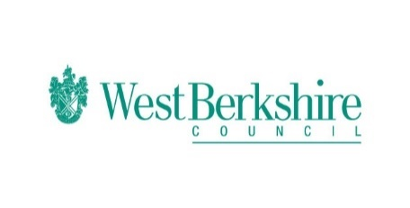
Bitesize Programme – Week Seven – Wednesday 10.06.20
Wednesday 10.06.20
Bitesize
Year 1 | English  Using zig zag letters in writing  https://www.bbc.co.uk/bitesize/articles/zd7wg7h  Maths  Counting in 10’s  https://www.bbc.co.uk/bitesize/articles/z6dr92p  Science  Squashing, bending, twisting and stretching  https://www.bbc.co.uk/bitesize/articles/zh4xprd
Year 2 | English  Using commas in lists  https://www.bbc.co.uk/bitesize/articles/zrqdbqt  Maths  Finding a half of a shape and an amount  https://www.bbc.co.uk/bitesize/articles/zwphjsg  Science  Squashing, bending, twisting and stretching  https://www.bbc.co.uk/bitesize/articles/z4yw2fr
Year 3 | English  Using a thesaurus  https://www.bbc.co.uk/bitesize/articles/zh2xhbk  Maths  Equivalent fractions  https://www.bbc.co.uk/bitesize/articles/zbqkvwx  Science  Renewable and non-renewable energy  https://www.bbc.co.uk/bitesize/articles/zhvc86f
Year 4 | English  Using a thesaurus  https://www.bbc.co.uk/bitesize/articles/zf96ncw  Maths  Hundredths  https://www.bbc.co.uk/bitesize/articles/zb4jmyc  Science  Renewable and non renewable energy  https://www.bbc.co.uk/bitesize/articles/zm9jmyc
Year 5 | English  Relative clauses  https://www.bbc.co.uk/bitesize/articles/zkcd7sg  Maths  Round decimals with two decimal places to the nearest whole number and to the nearest tenth  https://www.bbc.co.uk/bitesize/articles/zm6g9mn  Science  Reversible and irreversible changes  https://www.bbc.co.uk/bitesize/articles/z4vc86f
Year 6 | English  Commas for charity  https://www.bbc.co.uk/bitesize/articles/zdy8qnb  Maths  Substitute into simple expressions and formulae  https://www.bbc.co.uk/bitesize/articles/zjs9whv  Science  Reversible and irreversible changes  https://www.bbc.co.uk/bitesize/articles/zndmhg8

