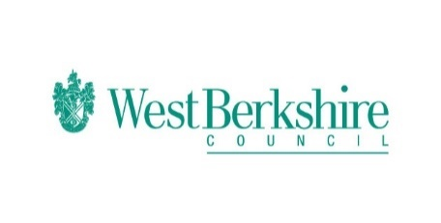
Bitesize Programme – Week Six – Thursday 04.06.20
Thursday 04.06.20
Bitesize
Year 1 | English  Using exclamation marks when writing  https://www.bbc.co.uk/bitesize/articles/z7ms3dm  Maths  Solve problems involving mass and capacity  https://www.bbc.co.uk/bitesize/articles/zhgsy9q  French  Counting, greetings  https://www.bbc.co.uk/bitesize/articles/z7c7639
Year 2 | English  Using noun phrases and exclamation marks in writing  https://www.bbc.co.uk/bitesize/articles/zmng9mn  Maths  Odd and even numbers  https://www.bbc.co.uk/bitesize/articles/zr23c7h  French  Counting, greetings  https://www.bbc.co.uk/bitesize/articles/zhg7639
Year 3 | English  Revising apostrophes for possession  https://www.bbc.co.uk/bitesize/articles/zhcsvk7  Maths  Non-unit fraction of an amount or set of objects  https://www.bbc.co.uk/bitesize/articles/zrytnrd  French  All about me and food and drink  https://www.bbc.co.uk/bitesize/articles/z64xprd
Year 4 | English  Revising apostrophes for possession  https://www.bbc.co.uk/bitesize/articles/znyf382  Maths  Problem solving with fractions  https://www.bbc.co.uk/bitesize/articles/z7pckmn  French  Clothes and food  https://www.bbc.co.uk/bitesize/articles/zn7vrqt
Year 5 | English  Using fronted adverbials  https://www.bbc.co.uk/bitesize/articles/zjbny9q  Maths  Fractions of amounts in contexts  https://www.bbc.co.uk/bitesize/articles/zdrbcqt  French  At school, hobbies and culture  https://www.bbc.co.uk/bitesize/articles/zmt74xs
Year 6 | English  Using parenthesis  https://www.bbc.co.uk/bitesize/articles/zm7w7nb  Maths  Find percentages of amounts  https://www.bbc.co.uk/bitesize/articles/zvxnv82  French  At school, hobbies and culture  https://www.bbc.co.uk/bitesize/articles/z93n7yc

