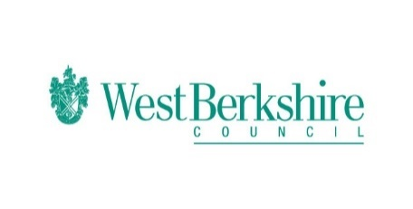
Bitesize Programme – Week Six – Monday 01.06.20
Monday 01.06.20
Bitesize
Year 1 | English  Using Capital Letters and full stops  https://www.bbc.co.uk/bitesize/articles/zv78jhv  Maths  Measure mass  https://www.bbc.co.uk/bitesize/articles/zdtq2sg  History  Who Was Queen Victoria?  https://www.bbc.co.uk/bitesize/articles/zvcsvk7
Year 2 | English  Using capital letters and punctuation  https://www.bbc.co.uk/bitesize/articles/zhh6pg8  Maths  10 times tables  https://www.bbc.co.uk/bitesize/articles/zk89d6f  History  Who was Gandhi?  https://www.bbc.co.uk/bitesize/articles/z777xyc
Year 3 | English  Revising Similes and metaphors  https://www.bbc.co.uk/bitesize/articles/zmg6pg8  Maths  Marking fractions on a number line below 1  https://www.bbc.co.uk/bitesize/articles/zm8g47h  History  The Iron Age  https://www.bbc.co.uk/bitesize/articles/zb3ny9q
Year 4 | English  Suffixes: -ous and –sion  https://www.bbc.co.uk/bitesize/articles/zr8kwty  Maths  Adding fractions  https://www.bbc.co.uk/bitesize/articles/zmhr92p  History  The Iron Age  https://www.bbc.co.uk/bitesize/articles/zrv4dty
Year 5 | English  Antonyms and synonyms  https://www.bbc.co.uk/bitesize/articles/z6q48xs  Maths  Multiply unit and non-unit fractions by an integer  https://www.bbc.co.uk/bitesize/articles/z6ghscw  History  Anglo Saxon art and culture  https://www.bbc.co.uk/bitesize/articles/zmyrcqt
Year 6 | English  Antonyms and synonyms  https://www.bbc.co.uk/bitesize/articles/z63ny9q  Maths  Convert fractions into percentages  https://www.bbc.co.uk/bitesize/articles/zvcny9q  History  Anglo Saxon art and culture  https://www.bbc.co.uk/bitesize/articles/z63ny9q

