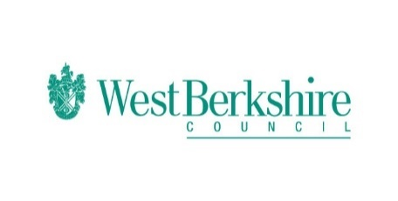
Bitesize Programme – Week Seven – Monday 08.06.20
Monday 08.06.20
Bitesize
Year 1 | English  Using phonics to develop vocabulary  https://www.bbc.co.uk/bitesize/articles/znf8qnb  Maths  Counting in 2’s  https://www.bbc.co.uk/bitesize/articles/z693rj6  History  Who was Ghandi?  https://www.bbc.co.uk/bitesize/articles/zfhvrqt
Year 2 | English  Developing vocabulary through phonics  https://www.bbc.co.uk/bitesize/articles/zxpx8hv  Maths  Unit fractions  https://www.bbc.co.uk/bitesize/articles/z4j83j6  History  Who was Elizabeth Fry?  https://www.bbc.co.uk/bitesize/articles/znt3c7h
Year 3 | English  Mastering inverted commas  https://www.bbc.co.uk/bitesize/articles/zjm6pg8  Maths  Drawing and discovering equivalent fractions  https://www.bbc.co.uk/bitesize/articles/zm6rkxs  History  How and why did the Romans invade Britain?  https://www.bbc.co.uk/bitesize/articles/z4dts4j
Year 4 | English  Mastering inverted commas  https://www.bbc.co.uk/bitesize/articles/zbvd7sg  Maths  Tenths  https://www.bbc.co.uk/bitesize/articles/zvyrkxs  History  How and why did the Romans invade Britain?  https://www.bbc.co.uk/bitesize/articles/ztryxbk
Year 5 | English  Direct and indirect speech  https://www.bbc.co.uk/bitesize/articles/zm63c7h  Maths  Understand and represent decimals with up to 2 decimal places as fractions  https://www.bbc.co.uk/bitesize/articles/zrsc86f  History  Anglo Saxon Art and Culture  https://www.bbc.co.uk/bitesize/articles/z3j9ydm
Year 6 | English  Apostrophes  https://www.bbc.co.uk/bitesize/articles/zrprkxs  Maths  Finding a rule with one and two steps  https://www.bbc.co.uk/bitesize/articles/zm6296f  History  Anglo Saxon Art and culture  https://www.bbc.co.uk/bitesize/articles/zxqkvwx

