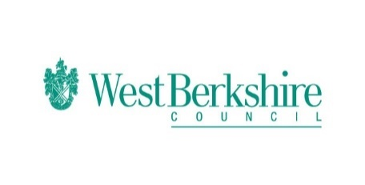
Bitesize Programme – Week Nine Monday 22.06.20
Monday 22. 06.20
Bitesize
Year 1 | English  Using Verbs  https://www.bbc.co.uk/bitesize/articles/z3y9vwx  Maths  Counting to 100  https://www.bbc.co.uk/bitesize/articles/z2xfxbk  History  Mary Seacole  https://www.bbc.co.uk/bitesize/articles/zk7mkty
Year 2 | English  Using Verbs  https://www.bbc.co.uk/bitesize/articles/z8d6wnb  Maths  Measure length and height  https://www.bbc.co.uk/bitesize/articles/zcbwr2p  History  Florence Nightingale  https://www.bbc.co.uk/bitesize/articles/zgvbhcw
Year 3 | English  Comprehension  https://www.bbc.co.uk/bitesize/articles/zqqxdp3  Maths  Turns and angles  https://www.bbc.co.uk/bitesize/articles/zwy3trd  History  Maya Civilisation  https://www.bbc.co.uk/bitesize/articles/zc6bp4j
Year 4 | English  Comprehension  https://www.bbc.co.uk/bitesize/articles/zs7tjsg  Maths  Making amounts of money  https://www.bbc.co.uk/bitesize/articles/zxfv6g8  History  Maya civilisation  https://www.bbc.co.uk/bitesize/articles/zb7mkty
Year 5 | English  Comics  https://www.bbc.co.uk/bitesize/articles/zvmmkty  Maths  Subtract decimals using formal method and involving exchange  https://www.bbc.co.uk/bitesize/articles/zk4kvwx  History  Kingdom of Benin  https://www.bbc.co.uk/bitesize/articles/zfbcf82
Year 6 | English  Comics  https://www.bbc.co.uk/bitesize/articles/zsmhqfr  Maths  Area and perimeter of rectilinear shapes  https://www.bbc.co.uk/bitesize/articles/znt3hcw  History  Kingdom of Benin  https://www.bbc.co.uk/bitesize/articles/zgkwr2p

