Welcome back to school!!
We are really looking forward to seeing all of your lovely smiley faces! Whilst it’s really exciting for you all to be coming back to school, it’s important for you to know that things might be a bit different to how you remember them. So we thought this may help!
Behaviour for good hygiene
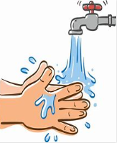  You are already very good at this! But when you return to school it’s really important that you wash your hands or use sanitiser when you come in to the building and when you leave it!  You will be cleaning your hands more often than usual - with running water and soap for 20 seconds, drying them thoroughly or using hand sanitiser ensuring that all of the hands are covered. | 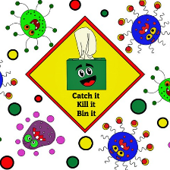  Remember good hygiene rules about sneezing and coughing. You must use tissues and put them in the bin (‘catch it, bin it, kill it’)  We know it’s really hard, but you should avoid touching your mouth, nose and eyes with your hands
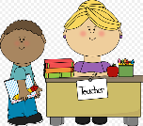
You must tell an adult if they are experiencing symptoms of coronavirus or feel unwell.
Behaviour for good organisation
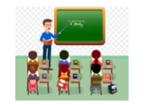  You might not be with your usual teacher and there will be less children in the class. You might be in a different classroom to the one you are used to. The classroom you are in might look a little different. There might be photos on the tables to remind you where to sit. These will be your friends to play with while you are at school. | 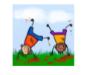  Lunchtimes and playtimes will be different. There won’t be any hot dinners and you will eat your lunch outside when the weather is nice. If it is cold or raining, you will eat in the hall with just your class. Classes will have lunch and playtimes at slightly different times. This is so we don’t have too many people in the playground at the same time and so you can play with only your class.
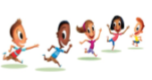  The climbing frames and equipment will be closed and not in use, but with less children in school you will have even more room for running around at playtimes! You will have a set space to play and stay in. You must follow adult instructions and not go anywhere else. | 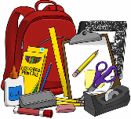  Your teacher will tell you where the toilets are that you can use and explain when these can be used. They will also give you your own equipment to use in school. The only things you are allowed to bring in are a lunchbox and a water bottle. You must not share any of your things with anyone else.
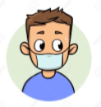  Some people might be wearing face masks, but this is nothing to worry about. It’s still the same, happy, smiling people underneath the masks! | 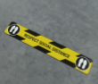  You will see tape both inside and outside of the school building. This is to show how far apart you need to try and stay from other people and also the places where you cannot go. There will be lots of signs up to help you too!
Behaviour to promote positive relationships
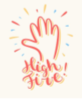  Because of the strict rules around social distancing, people in school won’t be able to hug each other or hold hands. Don’t worry though— you can do ‘air hugs’ and ’air high fives’. You must respect others space and feelings. At Speenhamland and Fir Tree we are always kind and respectful to everyone! | 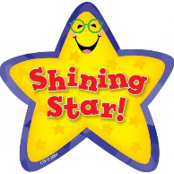  You will be rewarded for treating others kindly, trying your best and respecting the rules. Those who do not respect others and follow the rules will have a consequence because it is not fair on others.
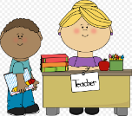
Remember you can tell an adult if you are feeling low or you are worried about your mental health.
Whilst some things will be different, there is one thing that will always be the same—the happy, smiling grown-ups waiting to welcome you back! We’ve missed you and can’t wait to see you!

